H.T No
Regulations:
A17

Sreenidhi Institute of Science and Technology
(An Autonomous Institution)
Code No: 6B202 Date: 23-Mar-2023 (AN)

B.Tech I-Year II- Semester External Examination, March/April-2023 (Supplementary)
ENGINEERING DRAWING – II (Common to All)

Time: 3 Hours Max.Marks:75
Note: a) No additional answer sheets will be provided.
b) All sub-parts of a question must be answered at one place only, otherwise it will not be valued.
c) Missing data can be assumed suitably.

Bloom's Cognitive Levels of Learning (BCLL)

Remember | L1 | Apply | L3 | Evaluate | L5
Understand | L2 | Analyze | L4 | Create | L6

Part - A Max.Marks:25

Answer all QUESTIONS.
 |  | BCLL | CO(s) | Marks
1 | Define Representative factor? | L1 | CO1 | [2M]
2 | Define i) full size scale and ii) Reducing scale | L2 | CO2 | [2M]
3 | State the principle of diagonal scale and Vernier scale. | L1 | CO3 | [2M]
4 | What is a sectional view and explain why sections are used in engineering drawing? | L2 | CO4 | [2M]
5 | State the difference between truncated and frustum of a solid | L1 | CO5 | [2M]
6 | What is stretch out or girth line. | L2 | CO6 | [3M]
7 | Explain why the projection of an object is not drawn in second and fourth quadrants. | L1 | CO1 | [3M]
8 | Define isometric scale. | L2 | CO1 | [3M]
9 | What is Vanishing point in perspective projections | Ll1 | CO1 | [3M]
10 | State the principle of visual ray method. | L2 | CO | [3M]

Part – B Max.Marks:50
ANSWER ANY FIVE QUESTIONS. EACH QUESTION CARRIES 10 MARKS.

 |  |  | BCLL | CO(s) | Marks
11. |  | Construct a diagonal scale of RF=1/4000 to show meters and long enough to measure up to 500 meters. | L4 | CO1 | [10M]
12. |  | Draw a Vernier scale of RF= 1/25 to read centimeters up to 4 meters and on it, show lengths representing 2.39m and 0.91m | L4 | CO2 | [10M]
13. |  | A hexagonal prism of side of base 30 mm and axis 70 mm long is resting on its base on HP. such that a rectangular face is parallel to VP. It is cut by a section plane perpendicular to VP and inclined at 300 to HP. The section plane is passing through the top end of an extreme lateral edge of the prism. Draw the development of the lateral surface of the cut prism. | L3 | CO3 | [10M]
14. |  | Draw the perspective projection of a point. A situated 20 mm behind the picture plane and 15mm above the ground plane. The station point is 30 mm in front of the picture plane, 40 mm above the ground plane and lies in a central plane which is 35 mm to the left of the given point. | L3 | CO4 | [10M]
15. | a) | Explain the sequence of commands used for generation of curves in CAD. | L2 | CO5 | [5M]
 | b) | List the advantages of CAD over manual drafting. | L1 | CO5 | [5M]
16. |  | Draw the orthographic view of the following figure  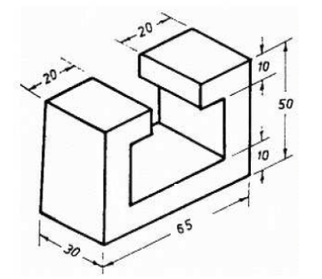 | L3 | CO6 | [10M]
17. |  | Draw the isometric view of the following figure  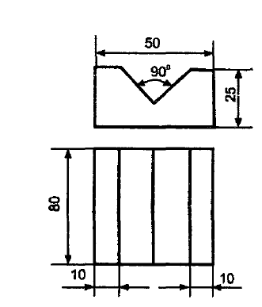 | L3 | CO1 | [10M]
18. |  | Draw the orthographic view of the below figure  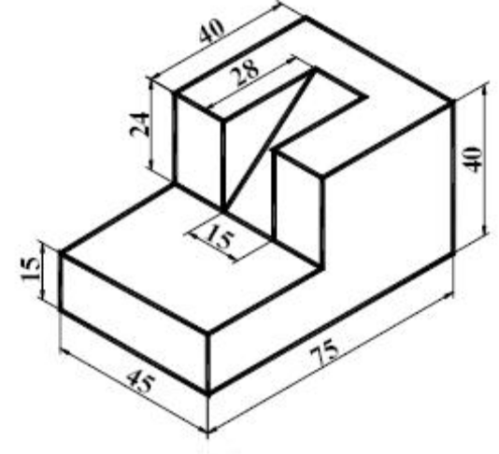 | L3 | CO4 | [10M]
-- 00 -- 00 –

